2023-2024 Brooklyn College

annual program assessment report

template

Section i. Program-Level Student Learning Outcome Assessment Status
Program-Level Student Learning Outcome (Program SLO) | Put an “X” if Data were Collected for this SLO in 2023-2024

#1: List Program SLO in full

#2: List Program SLO in full

#3: List Program SLO in full

#4: List Program SLO in full

#5: List Program SLO in full

#6: List Program SLO in full

Department:

Program Name:

NYSED CODE:

Table 1. Program-Level Student Learning Outcome (Program SLO) Data Collection for 2023-2024

Add rows for outcomes as needed

Section iI. Program Information

Table 2. Program Information

Description of Program (from Catalog):

Program Assessment Cycle Length:
Total Program Enrollment Fall 2023:
Program Coordinator/Contact*:
URL for published Program-Level Student Learning Outcomes (please complete URL):

*While a single coordinator may be completing the assessment report, program-level assessment is strongest when multiple faculty are participating in the assessment process.

Section III: Mapping of Program-Level Student Learning Outcomes to College Mission
Recoded Brooklyn College Mission Statement for Mapping
College Mission Statement | Code
Brooklyn College provides a transformative, distinctive, and affordable education to students from all backgrounds. We are proud of our history of intellectual freedom and academic excellence, as well as our location in a borough known for innovation, culture, and the arts. | CMS_1
We have a special commitment to educate immigrants and first-generation college students from the diverse communities that make up our city and state. | CMS_2
Our striving spirit reflects our motto: "Nothing without great effort." Through outstanding research and academic programs in the arts, business, education, humanities, and sciences, we graduate well-rounded individuals who think critically and creatively to solve problems. | CMS_3
They become leaders who transform their fields and professions and serve our increasingly global community. | CMS_4

Table 3. Alignment of Program-Level Student Learning Outcomes (Program SLOs) to College Mission
IMPORTANT NOTE. This only needs to be done once unless the Program SLOs and/or College Mission is/are updated.
Directions: Please indicate how each Program SLO aligns to the college mission by marking with an "X" or write a supporting statement of how the Program SLOs support the College’s mission below.

Program-Level Student Learning Outcome (Program SLO) | CMS 1 | CMS 2 | CMS 3 | CMS 4
Program SLO #1:
List the full Program SLO here
Program SLO #2:

Program SLO #3:

Program SLO #4:

Program SLO #5:

Add rows for outcomes as needed

Supporting Statement (required if Table 3 is not completed):

Section IV: Mapping of Program-Level Student Learning Outcomes to Institutional Outcomes
Table 4. Alignment of Program-Level Student Learning Outcomes (Program SLOs) to Institutional Outcomes
IMPORTANT NOTE. This only needs to be done once unless the Program SLOs and/or the Institutional Outcomes is/are updated.
Directions: Please indicate how each Program SLO aligns to the Institutional Outcomes by marking with an "X" or write a supporting statement of how the Program SLOs support the Institutional Outcomes.

Program-Level Student Learning Outcome (SLO) | Think critically and creatively | Effectively express their thoughts | Make sound ethical judgments | Integrate knowledge from diverse sources | Become an informed and responsible citizen of the world
Program SLO #1:
List the full Program SLO here
Program SLO #2:

Program SLO #3:

Program SLO #4:

Program SLO #5:

Add rows for outcomes as needed

Supporting Statement (required if Table 4 is not completed):

Section V: Assessment, Evaluation of Results, and Improvement Planning

One Program-Level Student Learning Outcome (Program SLO) is listed in this template, but please continue to populate the template for all outcomes you will be assessing in this report, i.e., Outcome 2, Outcome 3, etc.

1. Program SLO Assessed in 2023-24 – List Full Outcome

2. Data/Evidence & Evaluation Process.
There should be at least one piece of direct evidence of student learning for each Program SLO that is assessed. Middle States Commission on Higher Education examples of evidence are in Appendix A.
For the outcome, indicate what data/evidence was collected.

Course(s):

Number of Sections Offered:

Number of Sections Used to Conduct the Assessment:

Total Number of Students Assessed:

Assessment Instrument(s) Used to Collect the Data (e.g., capstone project, exam):

3. What were the results of the analysis of the assessment data?

4. Were there improvement strategies developed based on the assessment results?
If yes, discuss below.
If no, explain why (were program expectations met?) OR if improvement strategies are being planned and reported during the next academic year.

5. Was the Program SLO previously assessed between 2017-2018 and 2022-2023?
If yes, please indicate the year(s) of data collection and if any change in results was observed.
If no, please indicate “Baseline Year” below.

6. Discussion of Budgetary Considerations for Outcomes Assessment
Please provide a description and appropriate data-based justification for the following:
What, if any, resources or budgetary changes are needed within the program to address areas of focus suggested by the assessment data/evidence?

7. Comments

Appendix A

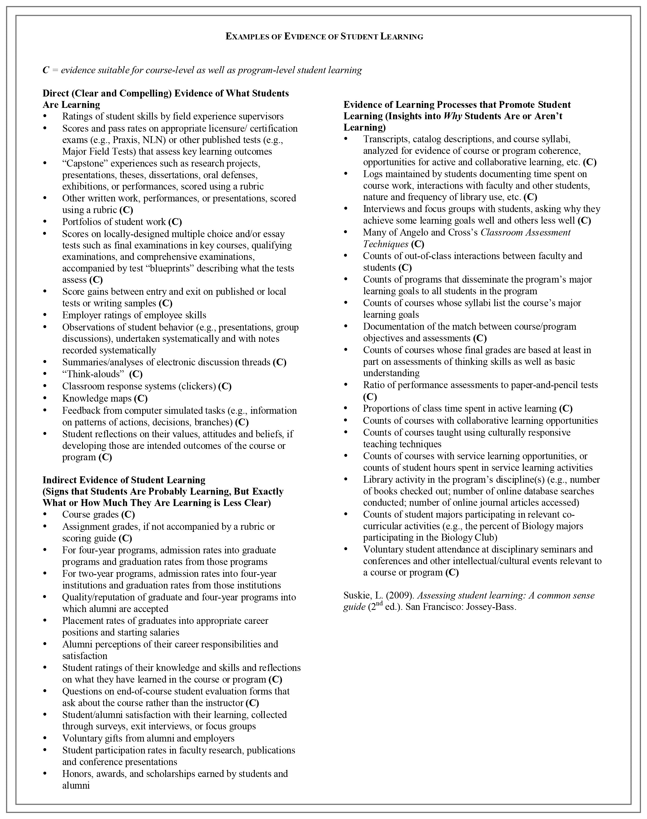
Document retrieved from MSCHE.org on March 14, 2018.

