Program Self-Study Template
[Year]

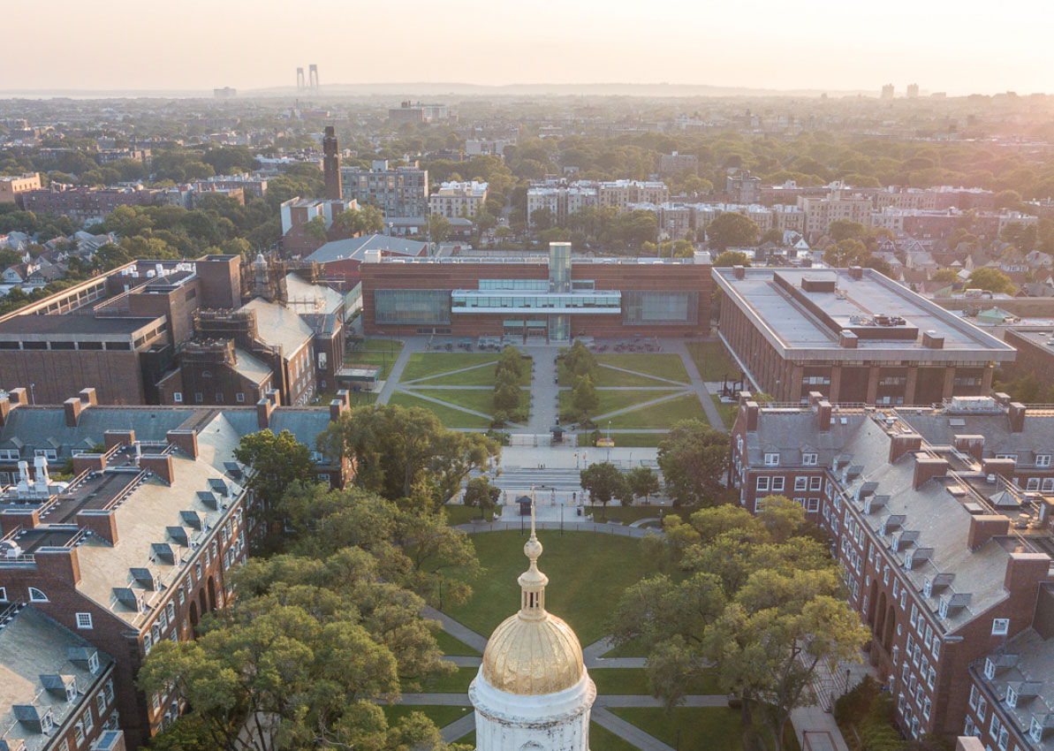

Elements of Program Review
Academic program reviews at Brooklyn College consists of a departmental/program self-study followed by a review by an external panel; the external review team’s report, and a discussion between the program and the administration about issues raised in the review.

*GUIDING PRINCIPLE (to be deleted before submission): The narrative of the self-study will address priorities such as academic excellence, research distinction, student success and well-being, societal and global impact, and inclusive campus culture.

Department or Interdisciplinary Program:

Program NYSED Code(s):

Self-Study Year:

Chairs:

Authors:

Editors:

Brooklyn College Self Study/External Review Requirements
Per the CUNY Board of Trustees requirement, each college must periodically conduct full reviews of all academic departments, and/or programs, and/or clusters of departments and/or programs. The requirement is designed to produce a self-study that:
- encourages members of a department to analyze its curriculum in relation to the goals of the department, the College, and the University;
- investigates the eﬀectiveness of its curriculum in relation to the desired outcomes as perceived by students, alumni, faculty members, and, where appropriate to the review of the program, professions, industries, and employers;
- reviews various characteristics to determine strengths and weaknesses;
- considers needed changes;
- evaluates the current levels of resources on the ongoing program;
- suggests needed changes in program, departmental organization, and resources.

Self-Study Checklist

In order to ensure compliance with the CUNY BOT policy, each self-study must address the following for each degree program the department oﬀers:
  - discussion of the goals of the program in relation to the mission of the department, college, and University
  - description of the curriculum, including introductory, major, and elective courses, as well as articulation and collaboration with other programs;
  - discussion of measures of program activity in such areas as courses and sections oﬀered and enrollments;
  - discussion of measures of faculty activities in such areas as teaching, research, and professional service;
  - discussion of the design and delivery of instruction;
  - discussion of measures of resources, in such areas as operating budgets, faculty, facilities, and equipment;
  - discussion of measure of program results, in such areas as retention, degrees awarded, and post-graduation experiences of students;
  - discussion of program quality as reﬂected in such measures as student course evaluations; external recognition of the program, faculty, and students; and surveys of the alumni; and direct assessment of program level student outcomes;
  - discussion of a plan for the future, to include such topics as curriculum development; faculty recruitment, retention, and development; and facilities and equipment development
Submitted by:

Signature of Department Chair Department Date
Brief and Condensed History of Brooklyn College:
Brooklyn College was founded in 1930 and was New York City’s first public coeducational liberal arts college. The school was envisioned as a steppingstone for the sons and daughters of immigrants and working-class people toward a better life through a superb—and at the time, free—college education. The first campus was set in the busiest section of downtown Brooklyn, within the shadows of Borough Hall and court buildings, and near a busy commercial thoroughfare. The current design of a Georgian-style campus facing a central quadrangle and anchored by a library building with a tall tower is the combined result of the college’s first president - William A. Boylan, and architect - Randolph Evans. Ground was officially broken on October 2, 1935, by NYC city Mayor Fiorello La Guardia, who in the presence of Boylan and Borough President Raymond V. Ingersoll, used a silver-plated shovel to symbolically signify the official beginning of Brooklyn College’s new campus. Through the efforts of Workers enlisted in the Works Progress Administration (WPA), most of the buildings and landscaping within of the campus were completed within two years.
The college’s reputation grew throughout the following decades, driven in part by a prominent faculty across the disciplines and in 1961, Brooklyn College became a member of the City University of New York (CUNY). Like many institutions the college experienced tumultuous times. Most notably, the Vietnam War, combined with the demands of emerging ethnic and racial empowerment movements, led to almost weekly protests. Both the student body and the faculty engaged in vigorous debates on and off campus, while the college became somewhat famous in the borough for hosting controversial figures, including Abbie Hoffman, Bob Dylan, and Malcolm X.
Despite this, the college was committed to the development and maintenance of curriculum that would make its students be among the city’s and the nation’s best. The college also committed to expanding its core facilities by adding new buildings such as The West Quad Center, and the Leonard & Claire Tow Center for the Performing Arts, which includes rehearsal and performance spaces, set design and construction workshops, ground-floor exhibition space, a double-height theater seating 200, a grand lobby and arcade, classrooms, and meeting and reception rooms.
The college’s most notable transformation occurred in 2011 with the creation of four new schools and the arrival of deans to head them. The existing School of Education was joined by the School of Business, the School of Humanities and Social Sciences, the School of Natural and Behavioral Sciences, and the School of Visual, Media and Performing Arts. In 2015, the School of Business was renamed the Murray Koppelman School of Business. Together, the schools foster collaboration across disciplines and allow for increased grant and research resources. Most especially, the formation of schools has increased the prominence of Brooklyn College and enhanced its reputation both in the academic world and in the greater community of Brooklyn and New York City.

Brooklyn College Mission Statement:
Brooklyn College provides an excellent, affordable, and transformative education to students who reflect the great diversity of our vibrant borough and country. We have a special commitment to educating immigrants and first-generation college students from our city and state. Through outstanding research and academic programs, we educate leaders who think critically and creatively to make positive change in the world.

Table of Contents
1. Program Mission Statement 1
1.1. Brief History of the Department 1
1.2. Program goals and objectives 1
1.3. Connection of program goals and objectives to BC Mission Statement 1
1.4. Connection of program goals and objectives to CUNY Mission Statement 1
1.5. Program executive Summary Statement 1
1.6. Program Commitment to Diversity, Equity, Inclusion and Equality 1
2. Resources 2
2.1. Full-time Faculty and Staff Resources 2
2.1.1. Faculty and Staff 2
2.1.2. Teaching loads 2
2.1.3. Scholarship and Professional Activity (publications, productions, presentations, other products of scholarship) 2
2.1.4. Outside Teaching and Service Activities 2
2.1.5. Evaluation 2
2.1.5.1. Scholarly and Professional Activity 3
2.1.5.2. Teaching 3
2.1.5.3. Service 3
2.1.6. Faculty Development Efforts 3
2.2. Adjunct Faculty 3
2.2.1. Recruitment 3
2.2.2. Selection 3
2.2.3. Supervision and Development 4
2.2.4. Evaluation 4
2.3. Organizational Structures 4
2.3.1. Administration 4
2.3.2. Interdisciplinary Collaborations 4
2.3.3. Oversight and Professional Integration 4
2.4. Physical Resources 5
2.5. Funding Resources 6
2.5.1. Revenue 6
2.5.2. Expenditures 6
2.6. CUNY and College Resources 6
3. Curriculum and Enrollments 7
3.1. Program Curriculum: Requirements and Curriculum Maps 7
3.1.1. Connection to Other College Programs 7
3.1.2. Evening, Weekend, and Summer Classes 7
3.2. Curriculum: Program for Student 8
3.2.1. Best practices, comparable programs, and specialized accreditation 8
3.2.2. Courses, Credits, and the number of sections offered 8
3.2.3. Course designs and instructional delivery 8
3.2.4. Required Internship or course other activities 8
3.2.5. Student Advisement 8
3.2.6. Student/Faculty Contact Outside Class 8
3.2.7. Relationship between Major and Specialized and Pre-Professional Programs 9
3.2.8. Courses Appended 9
3.3. Effectiveness of Curriculum 9
3.3.1. Assessment Activities 9
3.3.1.1. Methods and Instruments Used 9
3.3.1.2. Measured Effectiveness in Achieving Desired Objectives for: 9
3.3.2. Use of Assessment to Improve Programs 10
3.4. Students and Enrollments 10
3.4.1. Student Selection and Profile 10
3.4.1.1. Recruitment Process 10
3.4.1.2. Selection Process 10
3.4.1.3. Applicant Profiles 11
3.4.2. Enrollments and Retention 11
3.4.2.1. Enrollment and Retention Trends 11
3.4.2.2. Enrollment and Retention by Majors 11
3.4.2.3. Student GPA for program and overall 11
3.4.2.4. Student retention and completion rate for this program 11
3.4.2.6. Diversity Demographics 12
3.4.2.7. Career choices and Experiences after graduation 12
3.4.2.8. Program’s assistance with research experience, internship and job opportunities 12
3.4.2.9. External recognition of the program, its faculty and students 12
3.4.2.10. Program’s surveys of the alumni and their use in its improvement 13
4. Self-Analysis 14
4.1. What changes were made since the last self-study? 14
4.2. Program Goals and Objectives for the next 5 and 10 years 14
5. Summary and Conclusion 15
5.1. Questions and Advice Sought from External Reviewers 15
5.2. Significant Factors 15

Program Mission Statement

Brief History of the Department

Program goals and objectives

Connection of program goals and objectives to BC Mission Statement

Connection of program goals and objectives to CUNY Mission Statement

Program executive Summary Statement

Program Commitment to Diversity, Equity, Inclusion and Equality

Resources

Full-time Faculty and Staff Resources

Faculty and Staff

Teaching loads

Scholarship and Professional Activity (publications, productions, presentations, other products of scholarship)

Outside Teaching and Service Activities

Evaluation

Scholarly and Professional Activity

Teaching

Service

Faculty Development Efforts

Adjunct Faculty

Recruitment

Selection

Supervision and Development

Evaluation

Organizational Structures

Administration

Interdisciplinary Collaborations

Oversight and Professional Integration

Physical Resources

Funding Resources

Revenue

Expenditures

CUNY and College Resources

Curriculum and Enrollments

Program Curriculum: Requirements and Curriculum Maps

Connection to Other College Programs

Evening, Weekend, and Summer Classes

Curriculum: Program for Student

Best practices, comparable programs, and specialized accreditation

Courses, Credits, and the number of sections offered

Course designs and instructional delivery

Required Internship or course other activities

Student Advisement

Student/Faculty Contact Outside Class

Relationship between Major and Specialized and Pre-Professional Programs

Courses Appended

Effectiveness of Curriculum

Assessment Activities

Methods and Instruments Used

Measured Effectiveness in Achieving Desired Objectives for:

- Students while in Program

- Alumni of Program

Use of Assessment to Improve Programs

Students and Enrollments

Student Selection and Profile

Recruitment Process

Selection Process

Applicant Profiles

Enrollments and Retention

Enrollment and Retention Trends

Enrollment and Retention by Majors

Student GPA for program and overall

Student retention and completion rate for this program

      - Students’ perception of program’s quality as reflected in course evaluations

Diversity Demographics

Career choices and Experiences after graduation

Program’s assistance with research experience, internship and job opportunities

External recognition of the program, its faculty and students

Program’s surveys of the alumni and their use in its improvement

Self-Analysis

What changes were made since the last self-study?

Program Goals and Objectives for the next 5 and 10 years

Summary and Conclusion

Questions and Advice Sought from External Reviewers

Significant Factors

