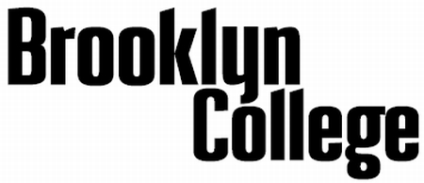

Report of
Annual Conference
Adjunct and Graduate Assistant Titles

Academic Year: | 2022-2023

Faculty Member:
Department:
Date of Conference:

The following form is intended as a guide for establishing goals, as well as providing a systematic record of the accomplishments of and feedback provided to faculty during the annual conference with their department chairperson. Elaboration is encouraged where appropriate—the fields in this Word document will expand as necessary.

* This version of the report includes only a teaching and student mentoring section.

[Revised February 2023]

Teaching & Student Mentoring

Summary of Accomplishments:

Goals for Current Year (from Previous Year’s Conference):

Progress Made Toward Current Year Goals:

Evaluation – Strengths:

Evaluation – Areas in Need of Improvement:

Performance Rating (Check One):

Exceeds Goals/Expectations
Meets Goals/Expectations
Meets Some Goals/Expectations
Does Not Meet Goals/Expectations

Note: The categories “Meets Some Goals/Expectations” and “Does Not Meet Goals/Expectations” indicate levels of performance that do not reach the minimally acceptable level for this category of evaluation during the current year’s review.

Goals for Next Year:

Additional Comments:

Report prepared by:

Chair or designee (Printed Name) |  | Signature |  | Date

I have read and received a copy of this report:

Faculty member (Printed Name) |  | Signature |  | Date

Note: The faculty member may not alter the content of this report. However, they may elect to prepare and append a statement.

